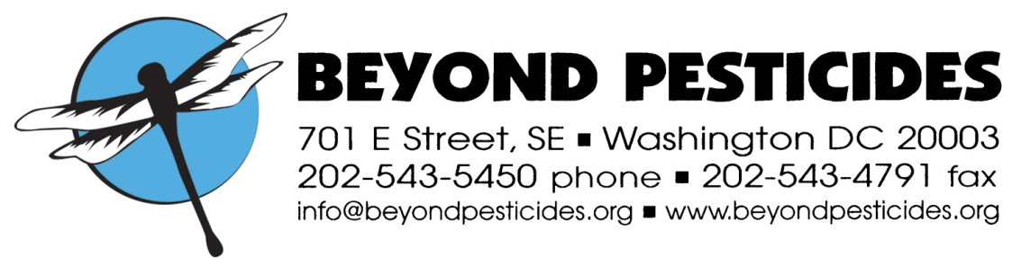

February, 2013

National Organic Standards Board
Spring 2013 Meeting
Portland, OR

Re. PDS: Materials Initiation Discussion Document

These comments are submitted on behalf of Beyond Pesticides. Beyond Pesticides, founded in 1981 as a national, grassroots, membership organization that represents community-based organizations and a range of people seeking to bridge the interests of consumers, farmers and farmworkers, advances improved protections from pesticides and alternative pest management strategies that reduce or eliminate a reliance on pesticides. Our membership and network span the 50 states and groups around the world.

We believe that there does need to be clear policy about what happens when a material comes to be considered by the Board through a process other than the usual petition process. Our principal concern is that the process be transparent and open to public comment. We believe the cases in which an alternative process would be used are, and should be, relatively rare.

Responses to questions:
- Should an NOSB subcommittee utilize the public petition process when proposing changes to the National List?
In general, the public petition process should be used when proposing changes to the National List. The public petition process provides needed information to the board and allows for public input in a recognized way.

- Are there situations when it would be appropriate for the NOSB to use an expedited or alternative petition process to consider a National List change? What are those situations?
There are situations —the consideration of the proposal to list rotenone on the list of prohibited natural materials is a good example—when it might be appropriate for a board subcommittee to initiate action. The board does hear from members of the organic community, and there are times when such action is needed, but there is no spokesperson to advance a petition. This seems to have been the case with rotenone. However, rotenone also exemplifies a problem because the subcommittee seemed to be so certain of the problem that it did not do a thorough examination of all aspects and seemed to be caught by surprise by banana growers.

We will address proposals raised by the National Organic Program (NOP) below.

- If the answer to #2 is yes, what elements to the process are important to ensure transparency and facilitate public involvement, such as posting on the petition database or similar database?
The same notification procedures, including posting of information that would be included in a petition and posting of any technical reviews, should be followed.

- How and when should the public be notified that the NOSB has initiated a review if it is added to the work plan?
Public notification procedures should be the same as for a petition coming from the public.

- Is it reasonable to interpret the NOSB-NOP Collaboration section of the PPM (p25), #2 Recommendation for modification of existing standards or new standards, as quoted above, to include the listing, delisting, or annotating National List materials?
It is reasonable to interpret that section of the PPM to include materials issues raised by the NOP. However, it would be best to clarify the issue by adding new language, such as “The NOP may request that the NOSB develop recommendations for new or existing standards, including review of new or existing materials.“

- Is the current system for determining the priority of reviews (PPM, p.49) acceptable? If not, please list any concerns?
The current priority system is fine.

- Are there other related issues that should be raised?

Thank you for your consideration of these comments.

Sincerely,

Terry Shistar, Ph.D.
Board of Directors

